Odoo Field Service – Equipment

Contents

What is Field Service Equipment? 1

Accessing Equipment 1

From Field Service Locations 1

All Equipment 2

Creating Equipment 2

# What is Field Service Equipment?

Field Service Equipment are devices located in the field at a location that are used for maintenance and asset tracking. The Field Service Equipment extends the maintenance module and adds additional support for Field Services. Throughout the field service order process, equipment may be required to be selected, like if it’s a maintenance or repair order for example.

# Accessing Equipment

Equipment is accessible from within each location or in the menu you can see all equipment.

## From Field Service Locations

When viewing a field service location, you can see related equipment to that location and can be accessed via the Equipment smart button on the location form.

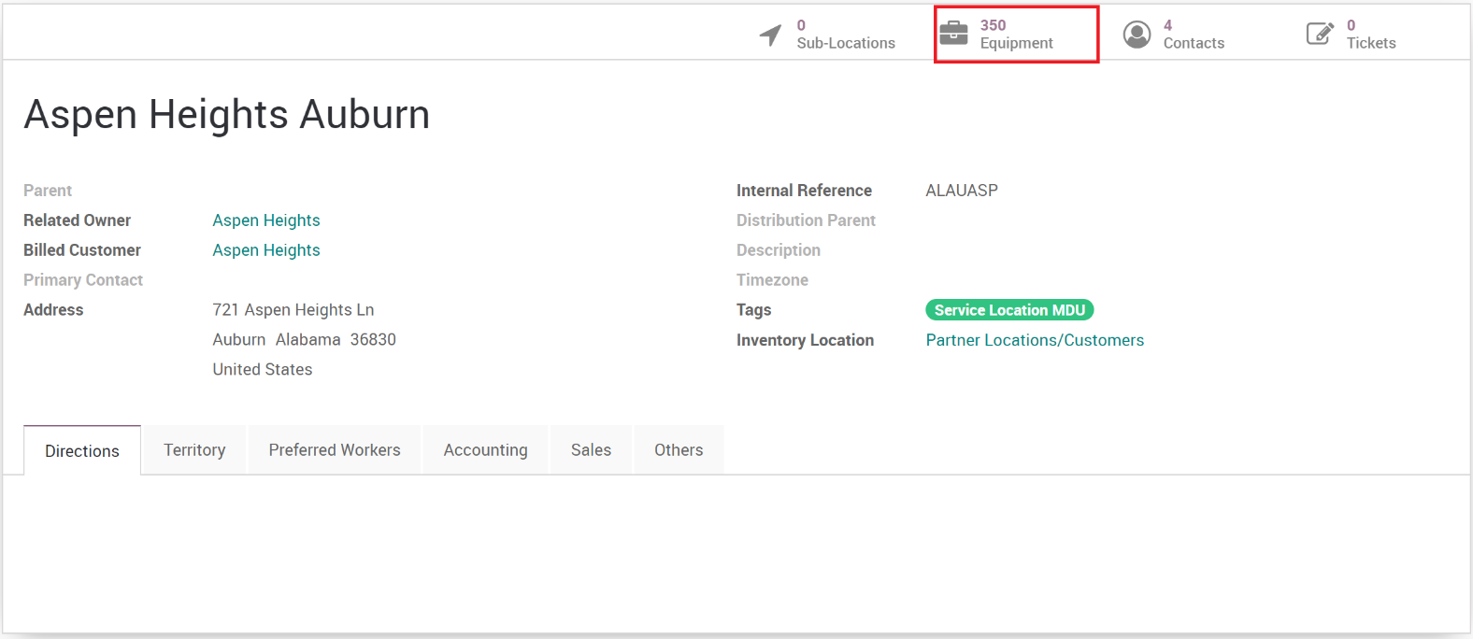

Clicking the smart button will open the equipment list related to the location and its child locations.

**IMPORTANT:** The smart button counts all equipment in the currently opened location, as well as all child locations and their equipment. If you open a sub-location, you will see the count for that location as well as any other child location related to that sub-location. So, opening the highest parent location will give you ALL equipment for that location.

## All Equipment

You can view all field service equipment by going to Master Data then Equipment. This list can then be searched, filtered or grouped by using the built in Odoo filter functions.

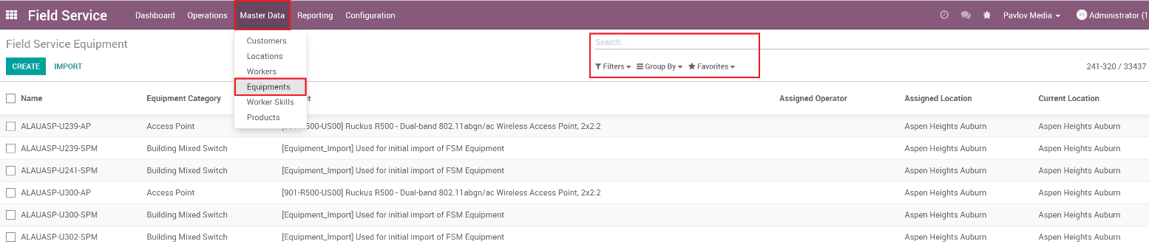

# Creating Equipment

You can either create equipment from the main equipment list in Master Data menu or by opening the location then via the Equipment smart button. Ether way you will get the same form, however if you open from the location, some fields may auto-populate with data from the location.

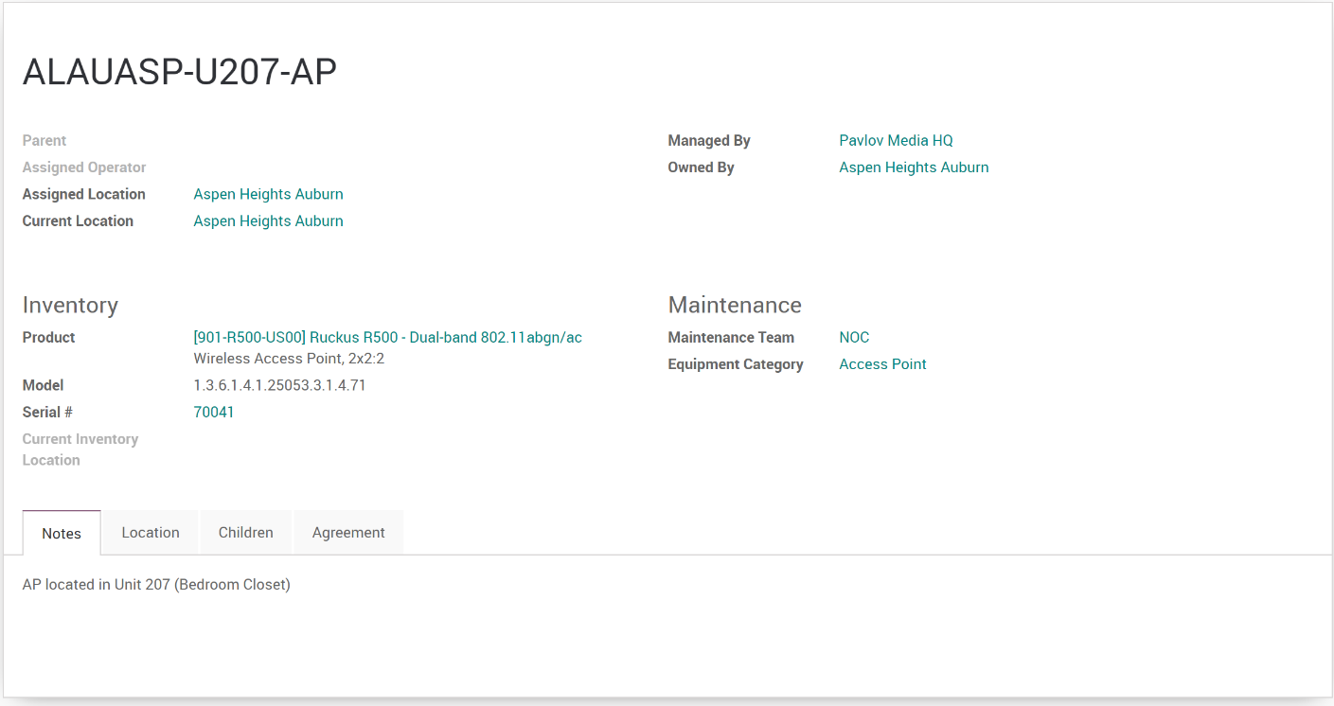

Field Descriptions:

* **Name**: The name of the equipment.
* **Parent**: Equipment can be setup in a hierarchy, so the parent would be the parent equipment the device is connected to.
* **Assigned Operator**: Used to assign the equipment to an individual or company if desired.
* **Assigned Location**: Used during staging and planning, when the equipment is allocated to be placed at a location.
* **Current Location**: Where the equipment is currently installed.
* **Managed By**: Who is managing the equipment.
* **Owned By**: Who owns the equipment.
* **Product**: The inventory product of the equipment.
* **Model**: The model of the equipment.
* **Serial #**: The serial number of the product.
* **Current Inventory Location**: Used to track inventory, if the equipment is kept at an inventory location.
* **Maintenance Team**: What team manages and maintains the equipment.
* **Equipment Category**: Equipment Categories are assigned for easier searching and sorting of equipment.
* **Notes**: Text field to add notes specific to this equipment, allowing for more details on the device.
* **Location (Territory)**: The territory information for the equipment, usually set to what’s on the Location.
* **Children**: List of child equipment who have their parent field set to this equipment.
* **Agreement**: The agreement and service profile the equipment is linked to.